MSML604 - Introduction to Optimization

Project Proposal:

HVAC System Optimization for greenhouse farming

**Name:** [Sandeep Polavarapu Venkata Naga](mailto:spvn@umd.edu)

The project proposed is to design and analyze the best parameters for tuning a HVAC optimization system for greenhouse farming in order to minimize the total energy consumption and maximize yield.

Food consumption has been increasing gradually over the past couple of years.The requirement to grow more food has led us to create modern techniques to cultivate crops of higher yield whilst using lesser resources. One such innovation is the invention of greenhouse farming techniques.

Greenhouse farming is the process of growing crops within a closed and controlled environment, including factors such as

* Temperature,
* Humidity/Water,
* Lighting,
* Ventilation/Macro Nutrients (CO2)
* Micro Nutrients (Nitrogen, Potassium, Phosphorus)

The project takes into consideration these factors for plant growth in a greenhouse using a HVAC system to control - temperature, humidity and ventilation.

* Project Scope:
  + Excludes water and nutritional requirements.
  + Limited to a specific geographic area
  + Limited to one type of plant/crop.

The objective function would be a combination to minimize the cost of the HVAC system. This is a function of the following parameters: (might use some or all of these) along with the number of plants/yield, Area of the greenhouse etc.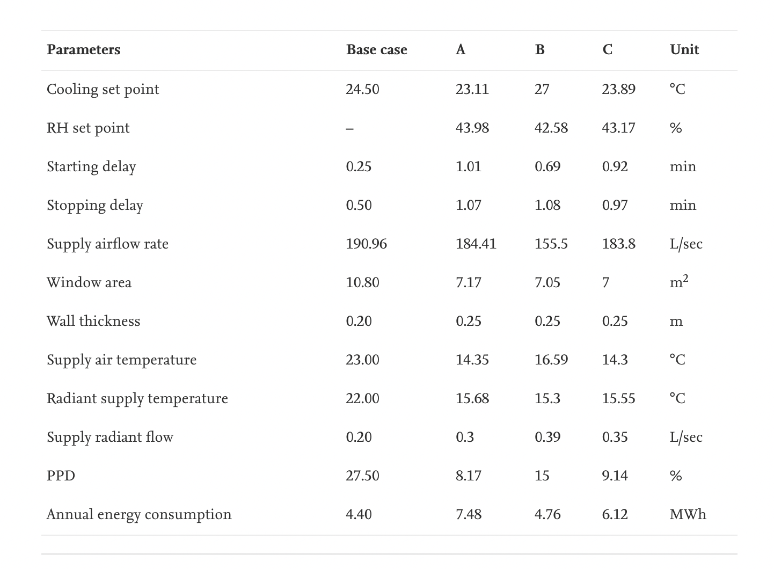

Source: <https://www.sciencedirect.com/science/article/pii/S2213138818305629>

The constraint functions would be the

* Limitations of the HVAC system (Avoid overheating, ensure physical feasibility)
* Necessary conditions required for plant growth
  + Light - potentially as a combination of natural sunlight and artificial lighting,
  + Humidity and
  + Temperature.
* Maintain a minimum amount of plant yield.
* Area of the greenhouse has to be positive.

Additionally, if time permits, the cost of water usage with its constraints can also be added with an idea to minimize water consumption. This concept can also be extended to vertical farming.